(SERIES I) **Name __________________________ Group___________**

**Biology Test #10 1stYear T.M: 10 T.T: 10min**

**Q:1 Choose the Correct Answer**  
**i carnivores plants live in soils that are deficient in**

1. **Water (b) oxygen (c) nitrogen** (d) iron

**ii the structure in the mouth that prevents entry of food into nasal cavity is**(a)soft palate (b)epiglottis(c)tongue (d)pharynx

**iii which of the following organism has no need for a gall bladder**

(A) cat (b)man (c)lion (d)goat

**iv a patient comes to you in hospital with complaints of abdominal discomfort, flatulence, nausea , vomiting and stomach acidity?**  
(a) pyrosis (b)ulcer (c)botulism(d) dyspepsia

**vmucus is secreted in git by**

(a) Glands(b)mucosa (c)goblet cells(d)mucosa cells

**Viparietal cells in stomach secretes**

1. hcl (b)pepsinogen (c)pepsin (d) mucus

**Vii initially digestion in ameba occurs in which medium**

(a) basic (b) acidic (c) ph 6.5 (d)ph 7.3

**Viii mychorrhizal fungus provides plants with water and mineralsespecially**

(a) copper (b)sulphur (c) phosphorus (d)nitrogen

**Ix all insectivores’ plants are actually**

(a) symbiotic (b) parasitic (c)autotrophic (d) heterotrophic

**X nucleic acid requires which of the following mineral**

(a) nitrogen (b)phosphorus (c) magnesium (d) sugar

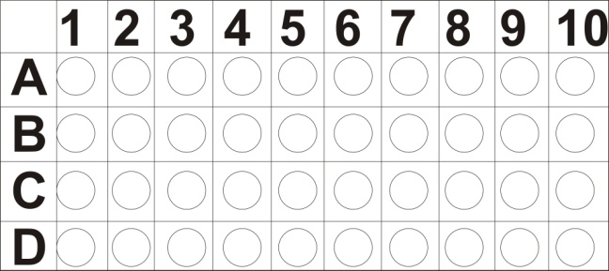

**Biology Test #10 1st year T.M: 30 T.T: 60 mins**

**Q:2Short Question(11 x 2 =22)**

1. Define chlorosis and Which factor is responsible for it?
2. Differ b/w saprophytic and symbiotic nutrition in plants?
3. Enlist the modes of nutrition in animals?
4. How gastrodermis helps in digestion in hydra?
5. What are the structures of foregut in cockroach and what functions are they performed?
6. Explain the agents responsible for lubrication and chemical digestion in oral cavity?
7. Define pyrosis and its causes?
8. How food poisoning is different from botulism?
9. Differentiate b/w anorexia nervosa and bulimia nervosa?
10. What are the functions f human liver?
11. Give exocrine function of pancreas?

**Q:3: Long Question (8)**

1. Explain briefly insectivores’ nutrition in plants? And why does it occurs?
2. Explain the structure and function of stomach?

**Head Office:**

351-6-CII-Azmat Chowk Green Town Lahore / 0423-5977454/ 03328734119



**Biology Test #10 1st year T.M: 30 T.T: 60 mins**

**Q:2Short Question(11 x 2 =22)**

1. Define chlorosis and Which factor is responsible for it?
2. Differ b/w saprophytic and symbiotic nutrition in plants?
3. Enlist the modes of nutrition in animals?
4. How gastrodermis helps in digestion in hydra?
5. What are the structures of foregut in cockroach and what functions are they performed?
6. Explain the agents responsible for lubrication and chemical digestion in oral cavity?
7. Define pyrosis and its causes?
8. How food poisoning is different from botulism?
9. Differentiate b/w anorexia nervosa and bulimia nervosa?
10. What are the functions f human liver?
11. Give exocrine function of pancreas?

**Q:3: Long Question (8)**

1. Explain briefly insectivores’ nutrition in plants? And why does it occurs?
2. Explain the structure and function of stomach?

**Head Office:**

351-6-CII-Azmat Chowk Green Town Lahore / 0423-5977454/ 03328734119